Unit 4 Pressure Measurement
State importance of pressure measurement in process industries.
The measurement of pressure is one of the most important measurements, as it is used in almost all industries. Some important applications of pressure measurement is listed.

  - The pressure of steam in a boiler is measured for ensuring safe operating condition of the boiler.
  - Pressure measurement is done in continuous processing industries such as manufacturing and chemical industries.
  - Pressure measurement helps in determining the liquid level in tanks and containers.
  - Pressure measurement helps in determining the density of liquids.
  - In many flow meter (such as venturimeter, orifice meter, flow nozzle, etc.,) pressure measurement serves as an indication of flow rate.
  - Measurement of pressure change becomes an indication of temperature (as used in pressure thermometers-fluid expansion type).
  - Apart from this, pressure measurement is also required in day-to-day situations such as maintaining optimal pressure in tubes of vehicle tires.

Define Pressure.
Pressure (P) is defined as the amount of force (F) acting per unit area (A). The mathematical equation for pressure can be written as:

P= F/A = mg/A
Where P is pressure F is the normal force (g is acceleration) and A is the area of the surface. Although the normal force is a vector quantity, pressure is a scalar quantity. The SI unit for pressure is the Pascal (Pa), equal to one newton per square meter (N/m2 or 1kg/(m-s2).

List and define different types of pressure.

Atmospheric pressure:

The pressure due to air surrounding the earth’s surface is called as atmospheric pressure.

Absolute pressure:
The pressure intensity measured from a state of prefect vacuum is called as absolute pressure.

Gauge Pressure:
A pressure measuring instrument generally measures the difference between the unknown pressure (p) and the atmospheric pressure (pa). When the unknown pressure (P) is greater than the atmospheric pressure (Pa), the pressure measured by the instrument is called as the gauge pressure.

Vacuum pressure:
A Pressure measuring instrument generally measures the difference between the unknown pressure (P) and the atmospheric pressure (Pa). When the atmospheric pressure (Pa) is greater than the unknown pressure (P), the pressure measured by the instrument is called as the vacuum pressure.

Static Pressure:
The pressure caused on the walls of the pipe due to a fluid at rest inside the pipe or due to the flow of a fluid parallel to the walls of the pipe is called as static pressure. This static pressure is measured by inserting a pressure measuring tube into the pipe carrying the fluid, so that the tube is at right angle to the fluid flow path.

Dynamic or Impact or Velocity pressure.

The pressure due to fluid velocity (flow speed) is called as impact pressure.

Impact pressure = Total pressure – static pressure.
Total or Stagnation pressure:
The pressure which is obtained by bringing the flowing fluid to rest is called as total or stagnation pressure. Hence the total pressure will be a sum of static pressure and impact pressure.

Pressure measuring instruments

Explain principle of working for Manometers.
A manometer works on the principle of hydrostatic equilibrium and is used for measuring the pressure (static pressure) exerted by a still liquid or gas. Hydrostatic equilibrium states that the pressure at any point in a fluid at rest is equal, and its value is just the weight of the overlying fluid.
P=h ρ g where, ρ = density of the liquid used in manometer. Hence, ρg = specific weight of the liquid.
In its simplest form, a manometer is a U-shaped tube consisting of an incompressible fluid like water or mercury. It is inexpensive and does not need calibration.

Explain Construction and Working of U tube manometer.

Construction:
It consists of a glass tube bent like the letter 'U'. In this type of manometer, balancing a column of liquid is done by another column of same or other liquid. One end of the U-tube is attached to the point where pressure is to be measured, while the other end is open to atmospheric pressure or connected to lower pressure. The pressure at point B in the figure is given by:

P = ρ2 g h2 - ρ1g h1

where, ρ2 = density of heavy liquid
h2 = height of heavy liquid above reference line ρ1 = density of light liquid
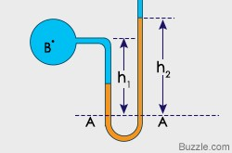

h1 = height of light liquid above reference line.
The manometer consists of a steel, brass and aluminum material. It has a glass tube made up of parallax glass. The graduations are made on the tube in terms of mm or in some condition it is graduated in kilo Pascal.

Working:
The unknown pressure is applied in the one arm of the tube and the mercury in the tube or manometeric liquid filled in the tube moves in the tube or rises to the constant region and then the movement is stopped. The height of the liquid is measured and pressure is calculated as per the equation given above.

Limitations: -
In the U-tube manometer, the application of pressure causes the liquid in one leg to go down while that in the other leg goes up, so there is no fixed reference. This tends to make the measurement of the height more difficult than it would be if one surface could be maintained at some fixed level.

Explain Construction and Working of Well-type manometer.
The principles of manometric measurements have been discussed in reference to the U-type manometer. However, the manometer has been arranged in other forms to provide greater convenience and to meet varying service requirements. The well type manometer is one of these.

Construction:
As illustrated in Figure, if one leg of the manometer is increased many times in area to that of the other, the volume of fluid displaced will represent very little change of height in the smaller area leg. This condition results in an ideal arrangement whereby it is necessary to read only one convenient scale adjacent to a single indicating tube rather than two in the U-type. The larger area leg is called the "well".

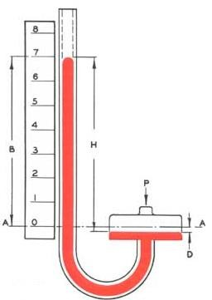
Working:

The higher pressure source being measured must always be connected to the well connection "P". A lower pressure source must always be connected to the top of the tube, and a differential pressure must always have the higher pressure source connected at the well connection "P". In any measurement the source of pressure must be connected in a manner that will cause the indicating fluid to rise in the indicating tube. The true pressure still follows the principles previously outlined and is measured by the difference between the fluid surfaces. It is apparent that there must be some drop in the well level.

Explain Construction and Working of Barometer.
A barometer is used to measure atmospheric pressure. Atmospheric pressure is a measure of the amount of force air exerts onto the earth as it is pushed down from the atmosphere. Another term for atmospheric pressure is barometric pressure.

Construction:
A classic mercury barometer is constructed from a glass tube that is open at one end and sealed at the opposite end. The glass tube is filled with liquid mercury and rests upside-down in a reservoir of mercury. As the mercury moves down the glass tube, a vacuum is created.

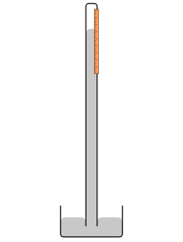
Working:
When the atmospheric pressure above the reservoir increases, the mercury inside the tube rises. As atmospheric pressure decreases the mercury moves down the tube, into the reservoir..
The change in the mercury level in the glass tube is equal to the pressure exerted by the air above the reservoir and is measured using the scale marked on the glass tube. Changes in atmospheric pressure occur prior to weather changes. Sudden drops in atmospheric pressure indicate stormy weather, while sudden rises in pressure predicate brief periods of fair weather. Gradual increases and decreases in atmospheric pressure point to a more sustained weather pattern.

Explain Construction and Working of Inclined leg type manometer.

Construction:
It is similar to a well type manometer in construction. The only difference being that the vertical column limb is inclined at an angle θ. Inclined manometers are used for accurate measurement of small pressure.

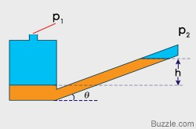
Working:

Many applications require accurate measurement of low pressure such as drafts and very low differentials, primarily in air and gas installations. In these applications the manometer is arranged with the indicating tube inclined, as shown in Figure, therefore providing an expanded scale.
Explain Construction and working of float type manometer.

Construction:
Let us now look at float-type manometers. This is a variation of well type manometer. We have a well with much larger diameter, and we have another tube another leg whose diameter is less than this. These two this well and this leg is connected by flexible connection, and this well diameter is larger than such that you can put a float inside. Now, this is connected to the high pressure source this is connected to the low pressure source.
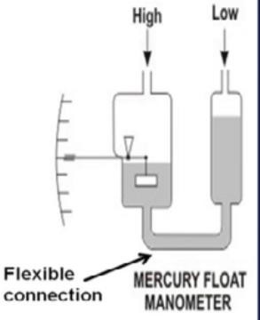
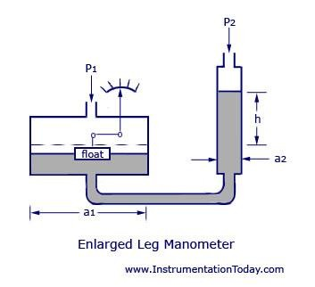 OR

Working:
Now as the manometer liquid changes its position the flow inside the well also changes its position, and the position of the float can be taken as a measure of pressure. We can choose a large flow, such that it generates enough force to move a pointer against the scale. So, the scale

can be calibrated in the unit of pressure and from the pointer under scale the pressure can be indicated.

By replacing the pointer by a plain, and by replacing the scale by a charge this float-type manometer can be converted to a recording type manometer. It is also easy to change the span of the measurement by changing the diameter of this leg. So, this is frequently called range tube since these two are connected by a flexible connection, if I change the diameter of this leg the span of the instrument can be easily changed. So, this is essentially a variation of well-type manometer, where replace a float in the well.

Explain Construction and Working of micro manometer.
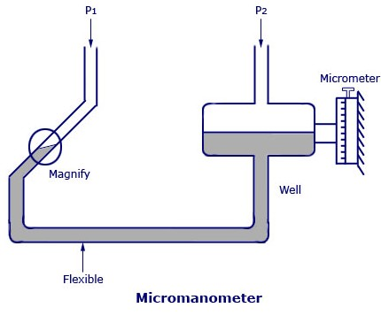
The micro manometer is another variation of liquid column manometers that is based on the principle of inclined tube manometer and is used for the measurement of extremely small differences of pressure.

Construction:
It is an extension of inclined lag manometer with flexible tube attached with the magnifier. There is a well where higher pressure (P2) is applied and lower pressure (P1) is applied at the tube section. Micrometer screw is attached with well to measure the minute change in level of well.

Working:
The meniscus of the inclined tube is at a reference level as shown in the figure below, viewing through a magnifier provided with cross hair line.
This is done for the condition, p1=p2. The adjustment is done by moving the well up and down a micrometer. For the condition p1 not equal to p2, the shift in the meniscus position is restored to zero by raising or lowering the well as before and the difference between these two readings gives the pressure difference in terms of height.

Explain Errors in Manometers.

Effect of Temperature
Manometers indicate the correct pressure at only one temperature. Another factor governing manometer’s accuracy is the scale. As with indicating fluids, temperature changes affect the scale. At higher temperatures the scale will expand and graduations will be further apart. The opposite effect will occur at lower temperatures.
Also the indicating fluid density changes with temperature. If water is the indicating fluid, an inch scale indicates one inch of water at 4°C only. On the same scale mercury indicates one inch of

mercury at 0°C only. If a reading using water or mercury is taken at 20°C then the reading is not an accurate reading. The error introduced is about 0.4% of reading for mercury and about 0.2% of reading for water. Since manometers are used at temperatures above and below the standard temperature, corrections are needed.

Capillary Effect

Capillary effects occur due to the surface tension or wetting characteristics between the liquid and the glass tube. As a result of surface tension, most fluids form a convex meniscus. Mercury is the only fluid that does not wet the glass, and consequently forms a concave meniscus. For consistent results, you must always observe the fluid meniscus in the same way, whether convex or concave. To help reduce the effects of surface tension, manometers should be designed with large bore tubes. This flattens the meniscus, making it easier to read. A large bore tube also helps fluid drainage. The larger the bore the smaller the time lag while drainage occurs.

Effect of Variable Meniscus
In order to achieve consistent results, the level of the meniscus on a manometer must be read with the eyes level to the meniscus. Placing the eyes level with the meniscus eliminates reading distortions caused by angle of reading, parallax, etc.

List advantages and disadvantages of manometers.

Advantages of Manometer:
  - Simple in construction
  - Low cost
  - Very accurate and sensitive
  - It can be used to measure other process variables.

Disadvantages of Manometer:
- Fragile in construction.
- Very sensitive to temperature changes.
- Error can happen while measuring the height.

Which fluids are used as a Manometric fluids?
Liquid manometers measure differential pressure by balancing the weight of a liquid between two pressures. Light liquids such as water can measure small pressure differences; mercury or other heavy liquids are used for large pressure differences.
Indicating fluids can be colored water, oil, benzenes, bromides, and pure mercury. When selecting an indicating fluid, check the specifications for specific gravity, operating temperature range, vapor pressure, and flash point. Corrosive properties, solubility, and toxicity are also considerations.

Explain Construction and Working of C-type Bourdon tube.

Principle:
When an elastic transducer (bourdon tube in this case) is subjected to a pressure, it deflects. This deflection is proportional to the applied pressure when calibrated.

Construction:

A C-type Bourdon tube consists of a long thin-walled cylinder of non-circular cross-section, sealed at one end, made from materials such as phosphor bronze, steel and beryllium copper, and attached by a light line work to the mechanism which operates the pointer. The other end of the tube is fixed and is open for the application of the pressure which is to be measured. The tube is soldered or welded to a socket at the base, through which pressure connection is made.
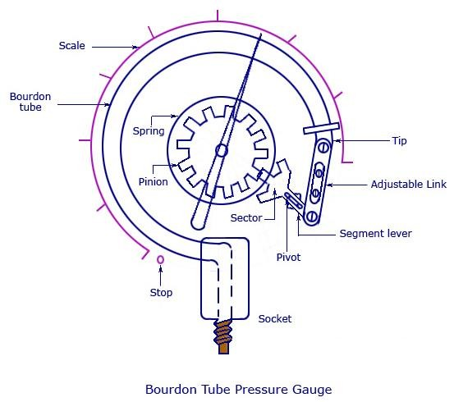
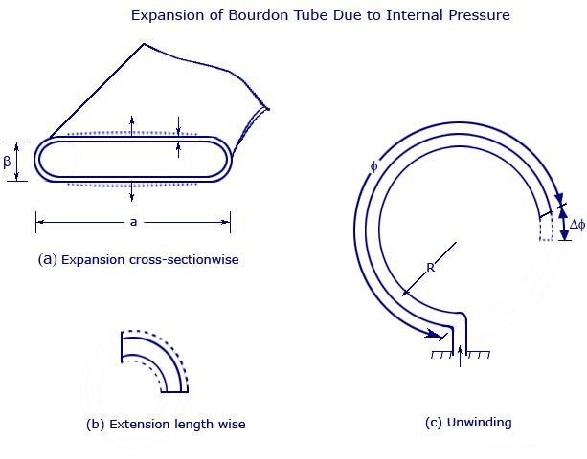

Working:
As the fluid under pressure enters the Bourdon tube, it tries to change the section of the tube from oval to circular, and this tends to straighten out the tube. The resulting movement of the free end of the tube causes the pointer to move over the scale. The tip of the Bourdon tube is connected to a segmental lever through an adjustable length link. The segmental lever end on the segment side is provided with a rack which meshes to a suitable pinion mounted on a spindle. The segmental lever is suitably pivoted and the spindle holds the pointer.
Bourdon tubes are made of a number of materials, depending upon the fluid and the pressure for which they are used, such as phosphor bronze, alloy steel, stainless steel, “Monel” metal, and beryllium copper.
Bourdon tubes are generally made in three shapes: C-type, Helical type and Spiral type

Which adjustments need to perform on bourdon tube? Explain each in brief.

Multiplication adjustment:
Because of the compound stresses developed in the Bordon tube, actual travel is nonlinear in nature. However, for a small travel of the tip, this can be considered to be linear and parallel to the axis of link. Small linear tip movement is matched with a rotational pointer movement. This is known as multiplication and can be adjusted by adjusting the length of the lever. Shorter lever gives larger rotation for same amount of the tip travel.


Angularity:
When the approximately linear motion of the tip is converted to a circular motion with the link lever and pinion attachment, a one-to-one correspondence between them may not occur and a distortion results. This is known as angularity. This can be minimized by adjusting the length of the link.

List advantages and disadvantages of Bourdon Tube.

Advantages:
  - These Bourdon tube pressure gauges give accurate results.
  - Bourdon tube cost low.
  - Bourdon tube are simple in construction.
  - They can be modified to give electrical outputs.
  - They are safe even for high pressure measurement.
  - Accuracy is high especially at high pressures.

Disadvantages:
- They respond slowly to changes in pressure
- They are subjected to hysteresis.
- They are sensitive to shocks and vibrations.
- Amplification is a must as the displacement of the free end of the bourdon tube is low.
- It cannot be used for precision measurement.

Explain Construction and Working of metallic and nonmetallic (Slack) Diaphragm pressure transducer.
A diaphragm pressure transducer is used for low pressure measurement. They are commercially available in two types – metallic and non-metallic.
Metallic diaphragms are known to have good spring characteristics and non-metallic types have no elastic characteristics. Thus, non-metallic types are used rarely, and are usually opposed by a calibrated coil spring or any other elastic type gauge. The non-metallic types are also called slack diaphragm.

Non Metallic (Slack) Diaphragm

Construction:
It is made up of rubber or other flexible material. Making a diaphragm slack rather than tight allows it to move large distance in response to a small pressure. A pointer is attached with the diaphragm via linkage. Pressure is applied at the input and is indicated on the scale.

Working

The diagram of a diaphragm pressure gauge is shown below. Unknown pressure is applied to the input (P1) of the gauge which will exerts force on the slack diaphragm. When a force acts against a thin stretched diaphragm, it causes a deflection of the diaphragm with its center deflecting the most. This movement is transferred to the pointer mechanism via leaf spring as shown in figure.
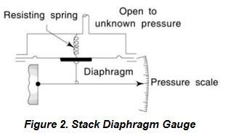
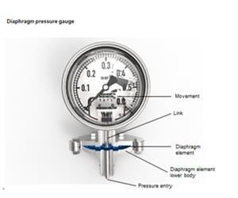
Figure 1 Non Metallic Diaphragm
Non-metallic or slack diaphragms are used for
measuring very small pressures. The commonly used materials for making the diaphragm are polythene, neoprene, animal membrane, silk, and synthetic materials. Due to their non-elastic characteristics, the device will have to be opposed with external springs for calibration and precise operation. The common range for pressure measurement varies between 50 Pa to 0.1 MPa.

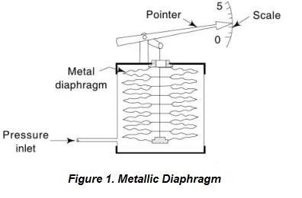
Metallic Diaphragm Construction:
Figure 2 Metallic Diaphragm
Since the elastic limit has to be maintained, the deflection of the diaphragm must be kept in a restricted manner. This can be done by cascading many diaphragm capsules as shown in the figure 2. A main capsule is designed by joining two diaphragms at the periphery. A pressure inlet line is provided at the central position.

Working:

When the pressure enters the capsule, the deflection will be the sum of deflections of all the individual capsules. This will also deflect the lever connected to the diaphragm. Through pivot, this movement of lever is transferred to the pointer and scale mechanism. As shown in figure, corrugated diaphragms are also used instead of the conventional ones.

List advantages and disadvantages of Diaphragm pressure gauge.


Advantages of Elastic diaphragm gauges:
  - Best advantage is they cost less
  - They have a linear scale for a wide range
  - They can withstand over pressure and hence they are safe to be used.
  - No permanent zero shift.
  - They can measure both absolute and gauge pressure, that is, differential pressure.

Disadvantages of Elastic diaphragm gauges:
- Shocks and vibrations affects their performance and hence they are to be protected.
- When used for high pressure measurement, the diaphragm gets damaged.
- These gauges are difficult to be repaired.

Explain Construction and Working of Bellows type pressure gauge.
Like a diaphragm, bellows are also used for pressure measurement, and can be made of cascaded capsules. The basic way of manufacturing bellows is by fastening together many individual diaphragms. The bellows element, basically, is a one-piece expansible, collapsible and axially flexible member. It has many convolutions or fold. It can be manufactured form a single piece of thin metal.
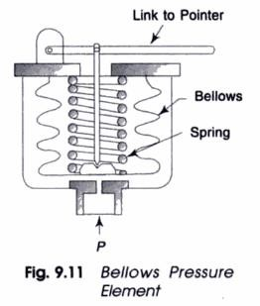
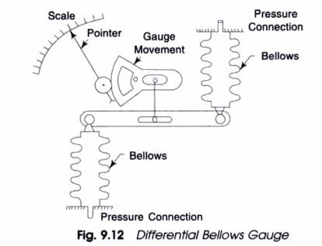

Construction:

A bellows gauge contains an elastic element that is a convoluted unit that expands and contracts axially with changes in pressure. Most bellows gauges are spring-loaded; that is, a spring opposes the bellows, thus preventing full expansion of the bellows. Limiting the expansion of the bellows in this way protects the bellows and prolongs its life. In a spring-loaded bellows element, the deflection is the result of the force acting on the bellows and the opposing force of the spring. The movement of bellows is transferred to a pointer though a linkage.
Bellows can also be used to measure differential pressure as shown in figure. Here two different pressure are applied to the two different pressure connection. Scale and Pointer is attached with gauge movement linkage at the center of the force bar. The bellows are connected between the input pressure connection and force bar.

Working:
The pressure to be measured is applied to the outside or inside of the bellows. However, in practice, most bellows measuring devices have the pressure applied to the outside of the bellows (see fig). As the inlet pressure varies, the bellows will expand or contract. This will move the linkage assembly and pointer will shows the applied pressure on the scale.
For differential pressure measurement using bellows, applied differential pressure will try to imbalance the force bar and accordingly this movement is transferred to scale via gauge movement and pointer.
Like Bourdon-tube elements, the elastic elements in bellows gauges are made of brass, phosphor bronze, stainless steel, beryllium-copper, or other metal that is suitable for the intended purpose of the gauge.
Although some bellows instruments can be designed for measuring pressures up to 800 psig, their primary application is in the measurement of low pressures or small pressure differentials.

.List advantages and disadvantages of Bellows type pressure gauge.
Advantages
- Bellow joints do not require access; i.e. They can be direct buried, however a telltale is recommended
- No maintenance is required.
- Low cost
- Can be used to measured differential pressure Disadvantages
- Bellows joints can fail catastrophically.
- No in place maintenance or repair can be performed - they must be replaced if damaged.

- Require that the system to be shut down when a failure occurs.
- Smaller pressure range of application.
- Temperature compensation needed.

Pressure measuring transducers

a) Explain principle of working for Strain gauge pressure Transducer.

When force is applied to any metallic wire its length increases due to the strain. The more is the applied force, more is the strain and more is the increase in length of the wire. If L1 is the initial length of the wire and L2 is the final length after application of the force, the strain is given as:
ε = (L2-L1)/L1
Further, as the length of the stretched wire increases, its diameter decreases. Now, we know that resistance of the conductor is the inverse function of the length. As the length of the conductor increases its resistance decreases.
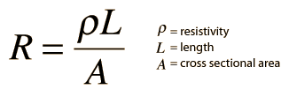
This change in resistance of the conductor can be measured easily and calibrated against the applied force. Thus strain gauges can be used to measure force and related parameters like pressure, displacement and stress. The input and output relationship of the strain gauges can be expressed by the term gauge factor or gauge gradient, which is defined as the change in resistance R for the given value of applied strain ε.

Explain Construction and Working of Strain gauge pressure transducer.

Construction:
Figure shows a bridge circuit with four strain gauges, Rsg1, R sg2, Rsg3 and R sg4. Two strain gauges, Rsg1 and R sg4 are mounted so that increasing pressure increases their resistance. Strain gauges Rsg2 and Rsg3, are mounted so that increasing pressure decreases their resistance. A change in temperature affects all the four strain gauges in the same way, resulting in no change in the pressure indication.

Working:
At balance, when there is no pressure, no current flows through the galvanometer G, and hence there will be no deflection in the galvanometer. As soon as the pressure is applied, the strain gauge stretches or compresses accordingly and the bridge circuit is unbalanced due to the change in resistance of the strain gauges. Thus, a current flows in the galvanometer, which is measured by the deflection of galvanometer. These changes affect the output of the bridge circuit, which indicates a change in measured pressure. Now, this change in output voltage may be calibrated for the pressure change.

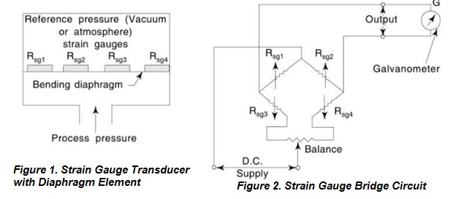


List advantages and disadvantages of Strain gauge pressure transducer.

Advantages:
- No moving parts
- Small and inexpensive
- Fast response time
- Ease of compensation for temperature effects
- Relative freedom from acceleration effects

Disadvantages:
- Non linear
- Needs calibration
- Inability to provide lower ranges (all)
- Low level outputs (all)
- Sensitive to environmental vibration (unbonded)
- Long term drift (all)
- Creep due to adhesive agents (semiconductor)

Explain principle of working for capacitive type pressure transducer.
The principle of operation of capacitive transducers is based upon the equation for capacitance of a parallel plate capacitor as shown below.

where:

C is the capacitance of the Capacitor in farad
𝐶 = 𝜀0𝜀𝑟𝐴
𝐷

A = Overlapping area of plates; m², D = Distance between two plates; m,
𝜀0 = 8.840 × 10⁻¹² farad/m²


𝜀𝑟
=
Relative Permittivity (dielectric constant); F/m.

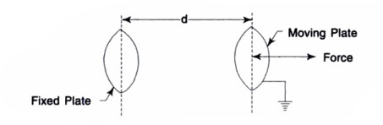


The capacitive transducers work on the principle of change in capacitance of the capacitor. This change in capacitance could be caused by change in overlapping area A of the plates, change in the distance D between the plates and change in dielectric constant
.

Explain Construction and Working of capacitive type pressure transducer.

Construction:
As shown in the figure below, a capacitive transducer has a static plate and a deflected flexible diaphragm with a dielectric in between. Diaphragm will expands and contracts due to change in pressure. These plats forms parallel plats capacitor which is connected as one arm of Wheatstone bridge circuit. Voltage output will give corresponding pressure measurement.

Working:
When a force is exerted to the outer side of the diaphragm the distance between the diaphragm and the static plate changes. This produces a capacitance change. This will unbalance the bridge and voltage output is measured in terms of applied pressure.
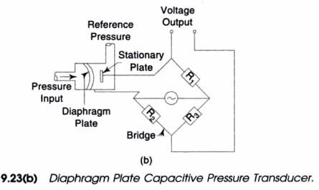

List advantages and disadvantages capacitive type pressure transducer. Advantages:
  - Construction is very simple.
  - Cost of the transducer is low.
  - Has very high sensitivity.


Disadvantages:
- An increase or decrease in temperature to a high level will change the accuracy of the device.
- Performance is affected by dirt and contaminations.
- As the lead is lengthy, it can cause errors or distortion in signals.

Explain principle of working for LVDT.

Definition of LVDT
The term LVDT stands for the linear variable differential transformer. It is the most widely used inductive transducer that covert the linear motion into the electrical signals.
It is called differential as the output across secondary of this transformer is the differential. They are very accurate inductive transducers as compared to other inductive transducers.

Principle of LVDT:
LVDT works under the principle of mutual induction, and the displacement which is a non- electrical energy is converted into an electrical energy.

Explain Construction and Working of LVDT.

Construction of LVDT
Main Features of Construction are as,
- The transformer consists of a primary winding P and two secondary winding S1 and S2 wound on a cylindrical former (which is hollow in nature and will contain core).
- Both the secondary windings have equal number of turns and are identically placed on the either side of primary winding
- The primary winding is connected to an AC source which produces a flux in the air gap and voltages are induced in secondary windings.
- A movable soft iron core is placed inside the former and displacement to be measured is connected to the iron core.
- The iron core is generally of high permeability which helps in reducing harmonics and high sensitivity of LVDT.

- The LVDT is placed inside a stainless steel housing because it will provide electrostatic and electromagnetic shielding.
- The both the secondary windings are connected in such a way that resulted output is the difference of the voltages of two windings.

Working:

As the primary is connected to an AC source so alternating current and voltages are produced in the secondary of the LVDT. The output in secondary S1 is e1 and in the secondary S2 is e2. So the differential output is,

eout = e1 - e2 This equation explains the principle of Operation of LVDT.
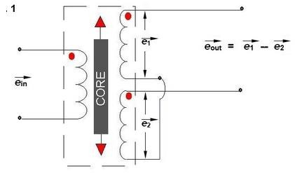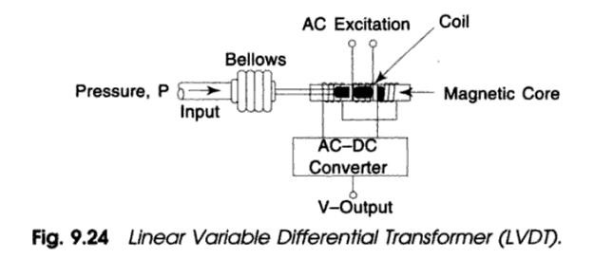
Now three cases arise according to the locations of core which explains the working of LVDT are discussed below as,

CASE I When the core is at null position (for no displacement)

When the core is at null position then the flux linking with both the secondary windings is equal so the induced emf is equal in both the windings. So for no displacement the value of output eout is zero as e1 and e2 both are equal. So it shows that no displacement took place.

CASE II When the core is moved to upward of null position (For displacement to the upward of reference point)

In this case the flux linking with secondary winding S1 is more as compared to flux linking with S2. Due to this e1 will be more as that of e2. Due to this output voltage eout is positive.

CASE III When the core is moved to downward of Null position (for displacement to the downward of reference point)
In this case magnitude of e2 will be more as that of e1. Due to this output eout will be negative and shows the output to downward of reference point.

Output VS Core Displacement
A linear curve shows that output voltage varies linearly with displacement of core.
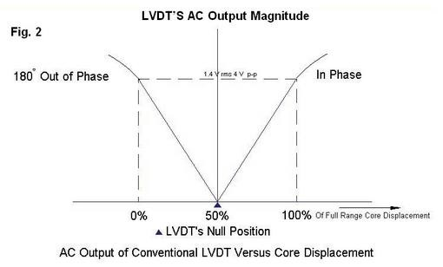

Some important points about magnitude and sign of voltage induced in LVDT
- The amount of change in voltage either negative or positive is proportional to the amount of movement of core and indicates amount of linear motion.
- By noting the output voltage increasing or decreasing the direction of motion can be determined
- The output voltage of an LVDT is linear function of core displacement.

List advantages and disadvantages of LVDT.

Advantages of LVDT
- High Range - The LVDTs have a very high range for measurement of displacement. They can used for measurement of displacements ranging from 1.25 mm to 250 mm

- No Frictional Losses - As the core moves inside a hollow former so there is no loss of displacement input as frictional loss so it makes LVDT as very accurate device.
- High Input and High Sensitivity - The output of LVDT is so high that it doesn’t need any amplification. The transducer possesses a high sensitivity which is typically about 40V/mm.
- Low Hysteresis - LVDTs show a low hysteresis and hence repeatability is excellent under all conditions
- Low Power Consumption - The power is about 1W which is very as compared to other transducers.
- Direct Conversion to Electrical Signals - They convert the linear displacement to electrical voltage which are easy to process

Disadvantages of LVDT
- LVDT is sensitive to stray magnetic fields so they always require a setup to protect them from stray magnetic fields.
- They are affected by vibrations and temperature.
It is concluded that they are advantageous as compared than any other inductive transducers.

Applications of LVDT
  - They are used in applications where displacements ranging from fraction of mm to few cm are to be measured. The LVDT acting as a primary transducer converts the displacement to electrical signal directly.
  - They can also acts as the secondary transducers. E.g. the Bourbon tube which acts as a primary transducer and covert pressure into linear displacement. Then LVDT coverts this displacement into electrical signal which after calibration gives the ideas of the pressure of fluid.

Explain principle of working for Piezo Electric pressure transducer.
The main principle of a piezoelectric transducer is that a force, when applied on the quartz crystal, produces electric charges on the crystal surface. The charge thus produced can be called as piezoelectricity.

Piezo electricity can be defined as the electrical polarization produced by mechanical strain on certain class of crystals. The rate of charge produced will be proportional to the rate of change of force applied as input. As the charge produced is very small, a charge amplifier is needed so as to produce an output voltage big enough to be measured.

Explain Construction and Working of Piezo Electric pressure transducer.

In 1880, Pierre and Jacques Curie determined that a small amount of voltage could be produced by applying large amounts of pressure to certain crystals of elements. This phenomenon is called the piezoelectric effect.

Construction:
When the piezoelectric effect is used in a pressure sensor, the sensor uses a diaphragm that deflects slightly when pressure is applied. A rod transfers this small amount of movement directly to the piezoelectric crystal Y1. The pressure on the crystal causes a small voltage to be produced that is proportional to the pressure. The voltage is amplified to traditional voltage signal values (0-10 volts) using charge amplifier. Crystal Y2 is for the purpose of compensation due to acceleration of device during use. Vibration is the major source of acceleration. Differential amplifier will subtracts all effects of accelerations and gives pressure alone.
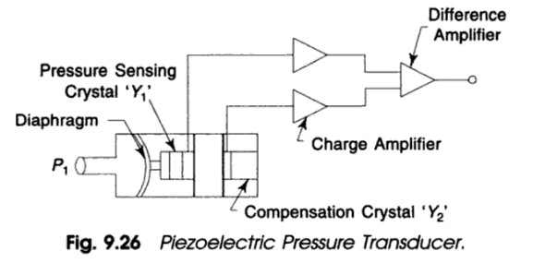

Working:
When pressure is applied to the diaphragm, it will deform the crystal Y1 and produce a small voltage. The amount of voltage is proportional to the amount of deformation. The amount of voltage that is produced is very small and the internal impedance of the crystal is very large, which makes the use of op amps a necessity to produce a usable signal. Charge amplifier will amplify the signals from both the crystals Y1 and Y2. Subtracted voltage at output of differential amplifier will be the calibrated in terms of the input pressure.
The best crystals that are used for this type of sensor come from ammonium dihydrogen phosphate and sintered ceramics.

List advantages and disadvantages of Piezo Electric pressure transducer.

Advantages
  - Very high frequency response.
  - Self-generating, so no need of external source.
  - Simple to use as they have small dimensions and large measuring range.

  - Barium titanate and quartz can be made in any desired shape and form. It also has a large dielectric constant. The crystal axis is selectable by orienting the direction of orientation.

Disadvantages
- It is not suitable for measurement in static condition.
- Since the device operates with the small electric charge, they need high impedance cable for electrical interface.
- The output may vary according to the temperature variation of the crystal.
- The relative humidity rises above 85% or falls below 35%, its output will be affected. If so, it has to be coated with wax or polymer material.

Explain Construction and Working of optical type pressure transducer.
Construction: Optical type pressure measurement is receiving considerable attention in recent years where the movement of a diaphragm, a bellows element or such other primary sensors are detected by optical means. The principle is nothing new, but the technique of adaptation in commercialization is varied in nature. A typical case with a diaphragm and a vane attached to it that covers and uncovers an irradiated photo diode with changing pressure is shown in the figure below. Reference diode is also used for the compensation.
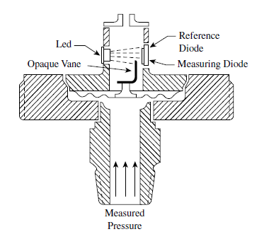

Working:

The movement of elastic pressure sensors can be used to operate optical sensors. As the process pressure moves a diaphragm sensor, which in turn lifts a vane in front of an infrared light beam, the amount of light impinging on the measuring diode varies (Figure). A reference diode is also provided to compensate for the aging of the light source (LED) or for dirt buildup on the optics.


Calibration may be made directly in pressure from output voltage of photo diode. The ratio metric technique is often preferred for avoiding drift error in electronic components as they are likely to be equally affected and cancelled. The vane movement or the diaphragm movement is kept small for negligible hysteresis and good precision. The range may be adjusted from (0-400) MPa with an accuracy of 0.1 percent scan.

Advantages:
  - This transducer is insensitive to temperature variations, as such variations affect the measuring and reference diodes in the same way.
  - Because the amount of movement in the sensor is very small (0.5 mm), both the hysteresis and the repeatability errors are negligible.

Disadvantages:
- Diode signals have non-linearity which may also vary from unit to unit.
- Signal conditioning circuit may require more attention.
- Temperature, though compensated, affects measurement to a certain extent which, in zero scale may be compensated by auto-zeroing facility.

Application:

This system is often used as a null detecting one in a force balance type pressure measurement, where the servo-system brings the sensor to the zero balance point.


Explain Construction and Working of Ring balance type pressure gauge or manometer.
This device cannot be actually called a manometer, but it is often considered so.

Construction:
The tube is made of polythene or other light and transparent material. This tube is bent into in to the form of a ring and is supported at the centre by a suitable pivot. The tubular chamber is divided in to two parts by spilling, sealing, and filling with a suitable light liquid like kerosene or paraffin oil for isolating the two pressures. Pressure taps are made with two flexible tubings. Pressures p1 and p2 act against the sealed walls as shown in the figure below, and rotate the ring which is balanced by the counter weight w.

Working:
The ring balance contains a sensitive element in the form of a hollow ring with a partition. A compensating weight is attached to the lower part of the ring, which is filled with a liquid (water, oil, or mercury). For p1 = p2, the liquid level in both sections of the ring is the same and the center of gravity of the weight is located on the vertical axis, which passes through the center of the ring. For p1 > p2, the liquid level in the left-hand part is lowered, and the liquid level in the right- hand part is raised. The force created by the action of the pressure difference on the partition generates a moment that tends to turn the ring clockwise. This angle θ is used to measure the pressure.
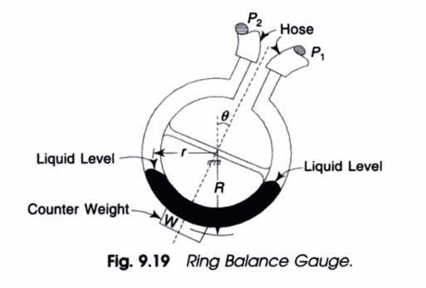

.

Explain Construction and Working of Pressure switch.
A pressure switch turns an electric circuit ‘ON’ or ‘OFF’ at a preset pressure. This pressure is called the set point of the switch. A pressure switch is used in some form of control, e.g. to operate a solenoid valve at a given pressure, or start up a pump.

Construction:
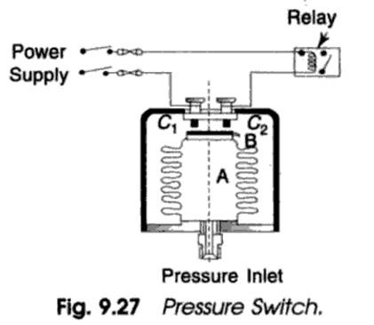
The pressure switch is usually a micro switch or a mercury switch. A Burdon tube, a diaphragm or a bellows can be used to actuate the switch. Figure shows the simplest form of a pressure switch is used to actuate relay.

Working:
The pressure is fed to the inside of a bellows which carries a contact plate B. When pressure reaches a sufficient (or preset) value, the contact plate touches contact points C1 and C2, thus

closing an electrical circuit to an alarm or motor control gear. The flexibility of the bellow ensures that the plate makes adequate contact with both points and gives a slight rubbing or wiping action that keeps the contact area clean.

The pressure switch can be modified so as to make a low pressure contact in addition to a high pressure contact. It is adjustable. The contact in a pressure switch may be normally closed when the pressure is below the set point. For example, the contacts in a normally open switch remains open until the pressure rises above the set point. Then the sensing element makes the contacts snap to the closed position. The contacts open again when the pressure falls below the set point. The contacts in a normally closed switch remain closed until the pressure rises above the set point. Then the contacts snap open and remain open until the pressure drops below the set point again. Most switches contains two sets of contacts, one normally open and the other normally closed.
A pressure switch has a “dead band”, i.e. the pressure must fall below the set point before the switch resets to its normal position. The amount of dead band is the difference in pressure between the set point and the reset point. The pressure switch is used to operate safety valve which vents steam when the pressure exceeds the upper limit.

Uses of Pressure Switches:
Following are the uses of pressure switches:
- One of the most important use of the pressure switch is in limiting pressure, e.g. in steam power plants. The pressure of the steam entering a turbine must not exceed an upper limit. The pressure switch is used to operate safety valve which vents steam when the pressure exceeds the upper limit.
- An important use of the pressure switch is in the computer panel. In the computer panel, blowers are used for cooling purposes. Whenever the blower fails due to any reason, a pressure switch is actuated which cuts off the power supply of the panel. Thus, the computer panel components are protected from the high temperature which can occur due to failure of the blowers.

